

CHALLENGE NAME: [The Summit]   
DEV : [Abhinav]

CATEGORY: [OSINT]   
LEVEL: []

2025



CHALLENGE NAME: [The Summit]

**Challenge Description**:   
Hey, I recently attended an event where I saw some notable guests on the first day. Unfortunately, I can't quite remember the exact location of the event. However, I do remember it was an important event with a lot of attention from the media. Can you identify the location of this event and find out who the prominent guests were? Use publicly available data to figure it out, and provide any additional insights you can gather about the event.

**Solution:**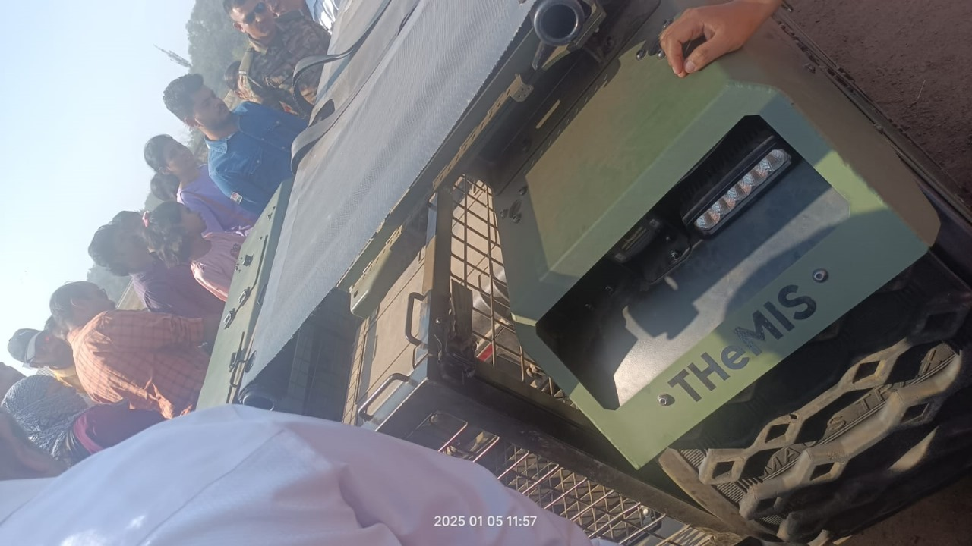Step 1: Identifying THeMIS  
Upon searching the internet, we can gather information about THeMIS. Based on our findings, we can deduce that it is related to military or defense, giving us a rough idea that this might be an army-related event.  
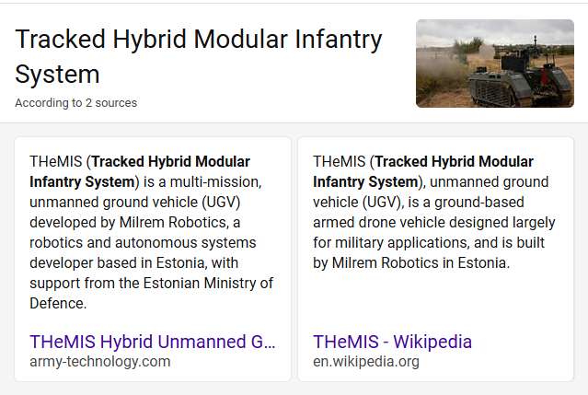

Step 2: Observing the Image Meta data by carefully analyzing the provided image, we can spot a date and timestamp. This is a crucial detail that can help us narrow down potential events happening around that timeframe.

Step 3: Correlating with Army EventsUsing the date extracted from the image, we perform a web search for army-related events that took place around that time. This leads us to discover that a “Know Your Army Mela” was conducted in multiple cities, including Pune and Hyderabad.  
Step 4: Finding the Location Based on Context in the challenge statement, it was mentioned that “I have visited the event”, which suggests that the event location should be near or within the participant’s city.

Using OSINT techniques, we can investigate and find that our club is associated with a college in Pune. This information strongly indicates that the event being referenced took place in Pune.  
Step 5: Refining the Search to Extract the FlagBy combining all gathered clues:

Date from the image

Army-related event (“Know Your Army Mela”)

Location (Pune)

We perform a more refined search that ultimately leads us to the final flag.

**Flag: VishwaCTF{18.51,73.89_Devendra Fadnavis}**

DEV: [] **1**